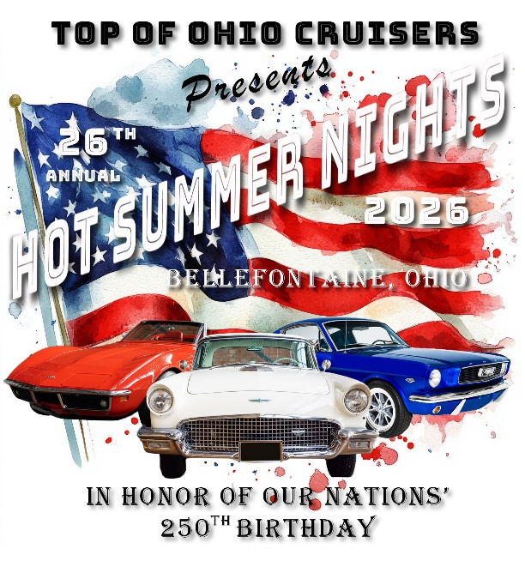
Saturday
August 8th, 2026
5:00 P.M – 8:00 P.M
NEW EARLIER TIMES
Downtown Bellefontaine
Limit first 400 cars
Registration $20- Free T-Shirt with pre-registration by July 24th
All participants MUST register at Fairgrounds Between 1-4 p.m. NO REGISTRATION DOWNTOWN
NEW EARLIER TIMES
Parade up Main Street to Downtown at 4:15
Downtown Show 5 – 8:00 p.m.
Awards at 8:00 p.m.
You must be present to receive an award. If not, that award will be given to the next highest vote recipient.
Door Prizes; Driver’s Pool; 50/50; $1000 Cash Raffle; Over 50 Awards.
All Cars, Trucks, Motorcycles, Specialty Vehicles Welcome
Rain or Shine
Corporate Sponsors:
Citizen’s Federal Savings & Loan * Auto Zone * Allen Tire, LLC. * Wammes Storage & Rentals, Ltd. * Mary Rutan Hospital * David Dailey’s State Farm Ins. * LeVan’s Body Shop * Robinaugh EMS, LLC * Old School Restoration, LLC * City Sweets & Creamery * Easton Water Solutions * Don’s Downtown Diner * Wreck-A- Mended 2 * Rustic Boutique *T & L Graphics * O’Reilly Auto Parts * Small Nation * Kerns Automotive * Taco Villa Authentic Mexican Food * Bellefontaine Lions Club * Alan Galvez Insurance * Mark & Alaina Robinson * Elite Cleaning & Concierge * Sam’s Auto Sales * Jan Wikerson Auto Care * Kingview Patners

IMPORTANT “HOT SUMMER NIGHTS” NOTES!
ALL PARTICIPANTS MUST REGISTER AT THE FAIRGROUNDS
THOSE NOT PARTICIPATING IN THE PARADE WILL BE PARKED IN DESIGNATED NON-PARADE SPACES IN THE DOWNTOWN AREA – NO EXCEPTIONS
PARADE LASTS APPROX.45 MIN.-BE AWARE THAT IT IS SLOW MOVING. IF YOUR VEHICLE CAN NOT HANDLE THE STRESS OF THIS TYPE OF SITUATION, YOU SHOULD NOTIFY A MEMBER OF THE TOP OF OHIO CRUISERS.
VOLUNTEERS ARE NEEDED TO HELP PARK THE PARADE CARS, IF INTERESTED PLEASE CONTACT THE CLUB PRIOR TO THE SHOW.
CLUBS SHOULD ARRIVE TOGETHER AT THE FAIRGROUNDS IN ORDER TO BE PLACED TOGETHER IN THE PARADE AND FOR DOWNTOWN PARKING.
NO ALCOHOL. NO FLAME THROWING. NO BURN OUTS.
The city of Bellefontaine will not suspend their DORA so please be aware that will be in place
AWARD WINNERS CHOSEN BY AWARD SPONSORS & LOCAL CELEBRITIES
TOP OF OHIO CRUISERS AND THE CITY OF BELLEFONTAINE ARE NOT RESPONSIBLE FOR ANY ACCIDENT OR INJURY.
ALL REGISTRATIONS ARE $20.00. PAID REGISTRATION RECEIVED BY JULY 24TH WILL RECEIVE A FREE T-SHIRT
CHECK US OUT ON FACEBOOK: Top of Ohio Cruisers
And www.topofohiocruisers.com
Email us at TopofOhiocruisers@gmail.com
Pre-Registration Form
Name Phone
Address
City State Zip
Email address

Car Make/Model
Please circle T-Shirt Size: S M L Xl XXL (Add $2.00) XXXL (Add $3.00)
Please send $20 S-XL, $22 for XXL, $23 for XXXL check/money order for pre-registration to:
TOP OF OHIO CRUISERS, PO BOX 893, BELLEFONTAINE, OH 43311

